Drum Equipments
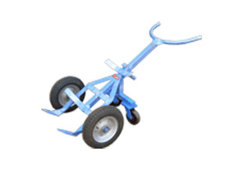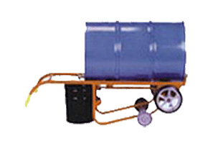

Ergonomic drum handling equipment. 4- Wheeler Drum trolley - With Pneumatic Wheels

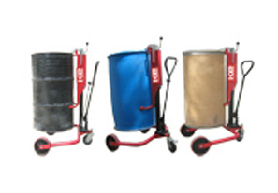

Lift and move steel/ Plastic drums easily, economically with the Hydraulic Drum Truck

Drum Lifters
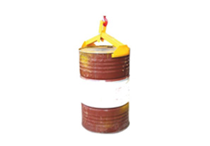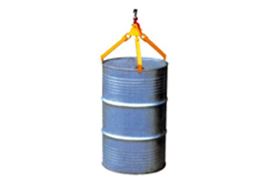

Drum Lifter. KE-DL350 (Through Hoist/ Hook Lifting) Drum Lifter. KE-DL360 ( Through Hoist/ Hook Lifting)

Drum Lifter Cum Tilter

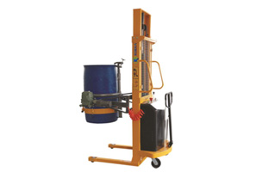

Electric Drum Rotator-with Battery Operated Drum Lifter. KE- YL450 (Electric Rotate180 degree)

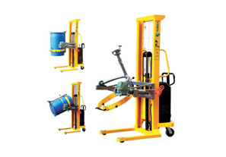

Semi-Electric Drum Lifter Cum Tilter KE-YL520

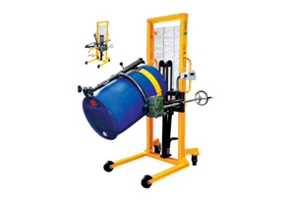

Drum Lifter with Scale. KE-DA450-1 (With Scale)

Drum Palletizer
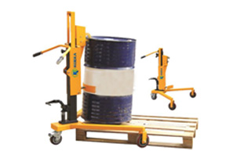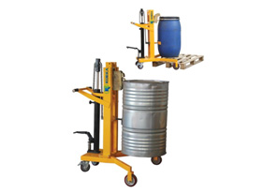

Hydraulic Drum Truck. KE-DT350B (Drum Palletizer) Hydraulic Drum Truck. KE-DTF450B (Drum Palletizer- More Lifting)

Drum Stacker
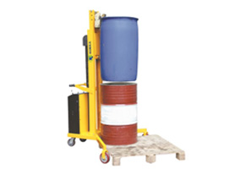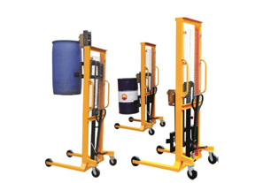

Semi-Electric Drum Stacker KE –DT300 (V-shaped Base) Multi-function of Lifting, Transporting, Stacking of Drums

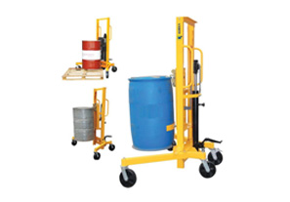

Hydraulic Drum Stacker KE-DT400 (Adjustable Support Legs)

Forklift Drum Grab

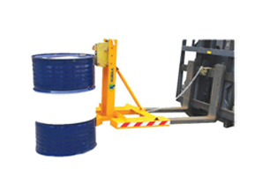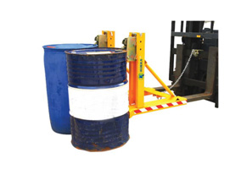

Fork Lift Drum Grab. KE-DG360A ( For Single Drum) Fork Lift Drum Grab. KE-DG720A (For Double Drum)

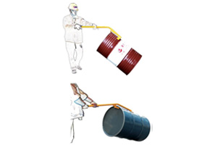

Drum Upender. KE-TY-50A

